|  |  |
| --- | --- |
| **www.MaterialsViews.com** | **www.afm-journal.de** |

**Physical Mechanisms behind the Field-Cycling Behavior of HfO 2 -Based Ferroelectric Capacitors** 

*Milan Pešic´ , Franz Paul Gustav Fengler , Luca Larcher , Andrea Padovani , Tony Schenk , Everett D. Grimley , Xiahan Sang , James M. LeBeau , Stefan Slesazeck , Uwe Schroeder , * and Thomas Mikolajick*

|  |  |
| --- | --- |
| **Novel hafnium oxide (HfO 2 )-based ferroelectrics reveal full scalability and complementary metal oxide semiconductor integratability compared to perovskite-based ferroelectrics that are currently used in nonvolatile ferro-electric random access memories (FeRAMs). Within the lifetime of the device, two main regimes of wake-up and fatigue can be identifi ed. Up to now, the mechanisms behind these two device stages have not been revealed.**  **Thus, the main scope of this study is an identifi cation of the root cause for the increase of the remnant polarization during the wake-up phase and subsequent polarization degradation with further cycling. Combining the comprehensive ferroelectric switching current experiments, Preisach density analysis, and transmission electron microscopy (TEM) study with compact and Technology Computer Aided Design (TCAD) modeling, it has been found out that during the wake-up of the device no new defects are generated but the existing defects redistribute within the device. Furthermore, vacancy diffu-sion has been identifi ed as the main cause for the phase transformation and consequent increase of the remnant polarization. Utilizing trap density spec-troscopy for examining defect evolution with cycling of the device together with modeling of the degradation results in an understanding of the main mechanisms behind the evolution of the ferroelectric response.** | HfO 2 dopants [ 2 ] in a binary mixture with ZrO 2[ 3 ] as well as for pure HfO 2 . [ 4 ] Even though a PZT-based ferroelectric fi eld effect transistor was already proposed by Moll et al., [ 5 ] these devices never reached the market due to their issues with scal-ability, compatibility with CMOS (com-plementary metal oxide semiconductor) processing, and the inherent depolariza-tion fi eld leading to retention issues. [ 6 ] An ever growing number of publications on ferroelectric-doped hafnia as well as the integration of the ferroelectric HfO 2 into the gate dielectric of the world’s smallest ferroelectric fi eld effect transistor (FeFET) [ 7–9 ] positions these thin fi lms as a game changer in memory technology, with full CMOS compatibility. [ 10 ] Two pos-sible paths for the realization of ferroelec-tric HfO 2 -based devices were considered: (a) FeFET; (b) metal ferroelectric metal (MFM) capacitor (FeCap).  Recently, transmission electron micros-copy together with electron diffraction |

was utilized to prove the existence of

**1. Introduction**

The discovery of the ferroelectric properties of silicon-doped hafnium oxide (Si:HfO 2 ) [ 1 ] offered the solution for the inte-gration and scalability of ferroelectric based devices. Since its discovery ferroelectric behavior has been proven for numerous

|  |  |
| --- | --- |
| M. Pešic´, F. P. G. Fengler, T. Schenk,  Dr. S. Slesazeck, Dr. U. Schroeder, Prof. T. Mikolajick NaMLab gGmbH/TU Dresden   Noethnitzer Str. 64 , Dresden D-01187 , Germany E-mail: uwe.schroeder@namlab.com  Prof. L. Larcher, Dr. A. Padovani   DISMI   Università di Modena e Reggio Emilia   Via Amendola 2, 42122 Reggio , Emilia , Italy |  |

E. D. Grimley, Dr. X. Sang, Prof. J. M. LeBeau   
 Department of Materials Science and Engineering North Carolina State University   
 Raleigh , NC 27695–7907 , USA

**DOI: 10.1002/adfm.201600590**

the orthorhombic Pca2 1 crystallographic phase, [ 11 ] which was previously only suggested [ 1 ] as a root-cause for ferroelectricity in HfO 2 . During the source/drain implant activation step, a fl ash anneal processing step at 1000 °C was applied. Besides the implant activation, the above-mentioned annealing step is conveniently used to crystallize the doped hafnia and to induce the ferroelectric phase. After the suc-cessful scaling to the state-of-the-art 28 nm high-k technology node [ 12,13 ] and device integration, [ 9,10 ] detailed studies of phys-ical mechanisms occurring within doped hafnium layers are needed. In general, memory devices require two or more dis-tinct states (binary 0 and 1 in case of the simplest two-level memory). The stability of these states has to be preserved for a certain number of cycles and after the required retention period depending on the application. [ 14 ] In case of the ferroelec-tric HfO 2 , a high-fi eld bipolar stress cycling impacts the mate-rial properties. The remnant polarization (i.e., *P*r value) evolves with cycling showing two distinct trends (see **Figure1** a):

(i) “Wake-up”: the remnant polarization memory window, re-lates as the difference between positive and negative rem-nant polarization, increases with cycling. This increase of the

|  |  |  |  |
| --- | --- | --- | --- |
| *Adv. Funct. Mater.***2016**, *26*, 4601–4612 | © 2016 WILEY-VCH Verlag GmbH & Co. KGaA, Weinheim | **wileyonlinelibrary.com** | **4601** |

|  |  |  |
| --- | --- | --- |
| **FULL PAPER** | **www.afm-journal.de** | **www.MaterialsViews.com** |
| fi lm. Moreover, a sketch of the potential interplay of defect |
| mechanisms to be aware of is derived from characterization |
| results and compared to literature. With this in mind, Sec- |
| tion 3 is devoted to investigation of the physical mechanisms |
| behind the wake-up and the fatigue stage. Furthermore, a |
| comprehensive modeling approach framework is developed |
| and introduced to explain the electrical data in terms of phys- |
| ical mechanisms responsible for the wake-up and the fatigue |

within the ferroelectric capacitor. 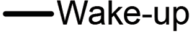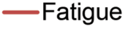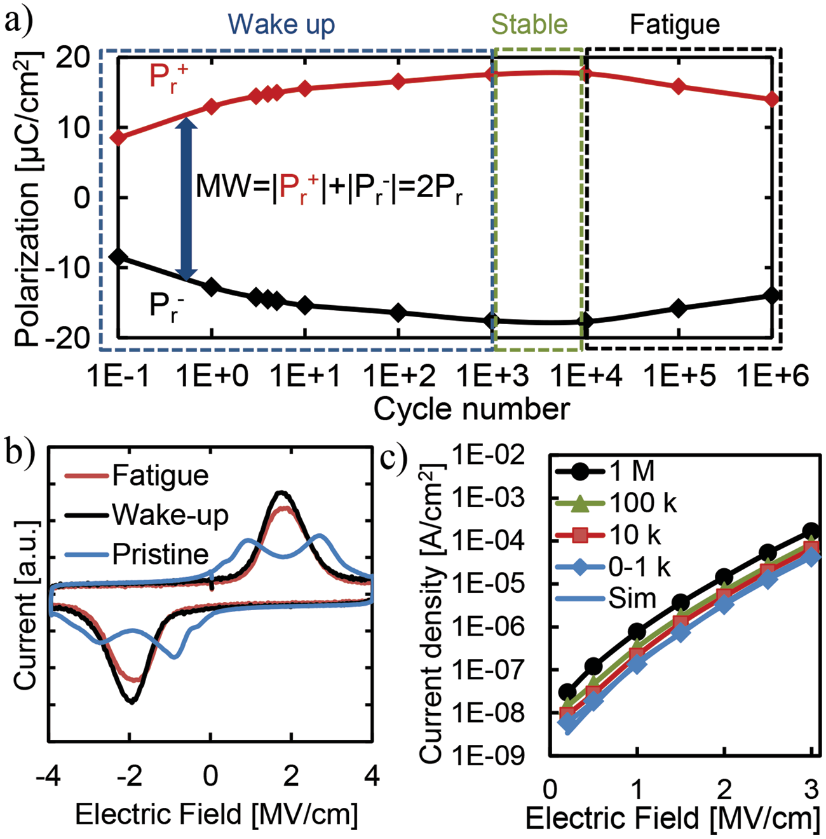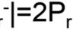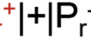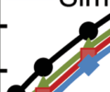

**2. Phenomenological Analysis**

Pristine doped HfO 2 samples are usually characterized by   
double peaks in the current voltage characteristic and conse-  
quently, a pinched hysteresis loop. It is reported that pristine   
double peak behavior may originate from different built-in   
fi elds within the device stack. [ 20 ] Different built-in biases or   
a different fi eld manifestation on different grains and even   
portions of the stack can occur due to a nonuniform defect   
distribution, polycrystallinity of the annealed fi lm and k-value   
nonuniformity. [ 21 ] In the following, a detailed characteriza-

**Figure 1.**  a) Evolution of the ferroelectric remnant polarization during bipolar cycling (4 V at 10 kHz) measured on Sr:HfO 2 -based ferroelectric capacitors. The difference between positive and negative remnant polari-zation defi nes the memory window. b) Current–voltage characteristics for three indicated regions. c) Leakage current evolution measured after different numbers of cycles with lines depicting the simulation (Sim).

remnant polarization, *P*r value corresponds with an opening or de-pinching of the pristine pinched hysteresis loop with fi eld cycling, [ 15,16 ] ;   
 (ii) “Fatigue” or aging: after a certain number of cycles, the rem- nant polarization hysteresis decreases resulting in a closure of the memory window (difference between positive and neg- ative remnant polarization) due to aging mechanisms. [ 17 ]

Wake-up and fatigue behaviors are due to a complex inter-play among phenomena involving the ferroelectric properties (e.g., domain orientation, phase stability and fi eld induced phase transitions) and dielectric characteristics (e.g., defect activation/creation, charge injection and consequent trapping), that could induce a built-in bias. [ 18,19 ] Even though those studies offered valuable fi rst step insight into the behavior of these new materials, they were confi ned only to potential mechanisms separately and in a speculative manner. Therefore, a detailed study of the physical mechanisms responsible for the wake-up and fatigue phase in doped hafnium fi lms is strongly required. To this aim, we will show in the present work a comprehensive collection of experimental results derived from the electrical characterization of the wake-up and the fatigue phenomena. For the fi rst time, we will interpret such results using a novel modeling approach, which will allow to point to the root cause of wake-up and fatigue phenomena in 10 nm thick strontium-doped hafnium oxide (Sr:HfO 2 ) based ferroelectric thin fi lms.

To address these fundamental challenges, initially, a detailed built-in bias screening evolution with fi eld cycling is presented in Section 2 . This is necessary to get an idea, of how charged defects and ferroelectric properties are distributed within the

tion and assessment of the mechanisms of the wake-up and fatigued stages will be presented.

**2.1. Built-In bias Screening**

The difference between positive and negative remnant polariza-tion, *P*r+ / *P*r− , is related to the memory window (MW). The MW evolution during cycling measured on Sr:HfO 2 -based capaci-tors is shown in Figure 1 . These types of plots are referred to as endurance plot with the word “endurance” being used to describe the ability of a material to withstand a certain number of switching cycles. The initial increase in the MW observed up to 10 3 cycles correlates with the “wake-up” effect as reported elsewhere. [ 15,16,20 ] With further fi eld cycling, the continuous switching of the polarization state reduces the MW.

Besides the polarization–voltage ( *P* – *V* ) characteristics meas-ured during the endurance test, the current–voltage ( *I* – *V* ) char-acteristics were examined. Figure 1 b represents the *I* – *V* curves measured on the ferroelectric capacitor at the three stages of the lifetime: (ii) pristine; (iii) woken-up; (iv) fatigue stage. The *I* – *V* characteristic measured on the pristine sample is charac-terized by two distinct current peaks, which move toward each other with continuous bipolar cycling, eventually merging in the wake-up regime. Since the polarization-voltage character-istic is the integral of the transient current, this behavior rep-resents a transition of the initially pinched hysteresis loop to a so-called open hysteresis. Further cycling results in a decrease of the remnant polarization amplitude, and the broadening of the current peak in the fatigue phase.

In parallel to the endurance behavior, the evolution of the static DC leakage current with the bipolar cycling was moni-tored (Figure 1 c). Leakage current spectroscopy represents a very powerful technique to examine the quality of a dielectric in terms of defects generated/activated within the dielectric layer during the bipolar cycling stress. Interestingly, leakage current remains constant up to 10 3 cycles, which corresponds to the

|  |  |  |  |
| --- | --- | --- | --- |
| **4602** | **wileyonlinelibrary.com** | © 2016 WILEY-VCH Verlag GmbH & Co. KGaA, Weinheim | *Adv. Funct.Mater.***2016**, *26*, 4601–4612 |

|  |  |
| --- | --- |
| **www.MaterialsViews.com**  wake-up stage. Further cycling resulted in signifi cant increase of the leakage current, accompanied by the reduction of the memory window as shown in Figure 1 a. The observed behavior indicates that new defects are generated within the dielectric stack during cycling resulting in an increased leakage current. On the other hand, the constant behavior of the leakage current in the fi rst 10 3 cycles suggests that in the wake-up phase, there is almost no generation of new defects assisting the charge transport through the trap-assisted tunneling (TAT) but a redis-tribution of the existing ones, as well as a change of their occu-pancy. Thus, the endurance trend in the wake-up phase seems to originate from changes in the ferroelectric properties of the Sr:HfO 2 layer. Nevertheless, defect creation/activation/diffu- | **www.afm-journal.de**  stack becomes more uniform. The change of the built-in bias could be related to the distribution changes of atomic defects within the stack, which can either trap charge thus changing their charge states and the internal fi eld (e.g., oxygen vacan-cies [ 21 ] ) as well as local changes of the material either by phase transformation or vacancy movement under the infl uence of fi eld and temperature.  With further cycling, the onset of the fatigue behavior is observed as the progressing decrease in *P*r . To gain insight into the fatigue phase, measurements were performed in sim-ilar manner as for the woken-up case. That is, after the device was stressed with alternating switching pulses for 10 6 cycles FORC measurements were recorded. The pseudo-color plots in |
| sion and charge trapping occurring within the dielectric layer | Figure 2 b,c (wake-up and fatigue case) show that the maximum |



cannot be in principle excluded and, thus, requires an in-depth analysis. To deepen this study and access this behavior from the perspective of the resulting internal fi eld, the fi rst-order reversal curve (FORC) technique was employed.

As reported by Schenk et al., [ 19 ] the FORC approach repre-sents a very powerful tool for the analysis of the evolution of the switching and back-switching fi eld distributions in doped HfO 2 -based ferroelectrics. This approach originates from the characterization of ferromagnetic materials [ 22 ] and has also been utilized for the characterization of the classic ferroelectric materials in the past decades. The FORC measurement proce-dure starts at a fi elds high enough to reach the saturation polar-ization, here the positive one. Subsequently, the fi eld is swept toward the negative direction and back to saturation, stepwise lowering the value of the reversal fi eld until the opposite (here the negative) saturation polarization is reached. A detailed [ 23,24 ] and simplifi ed mathematical treatment of the measured data as well as a coordinate transform to *E*c and *E*bias was described in Supporting Information S1. In contrast to the other studies, here the FORC technique is utilized to analyze the evolution of the build-in bias fi eld and coercive fi eld evolution with fi eld cycling of the device. As for the *I* – *V* characterization, the focus will be on pristine, wake up and fatigued phases, as shown in Figure 1 a. Utilizing the coordinate transformation (see Sup-porting Information S1) the Preisach density ρ is plotted as function of bias fi eld *E*bias and coercive fi eld *E*c in **Figure2** .

As shown in the Figure 2 a, the pristine sample is character-ized by two distinct regions in the Preisach/switching density plot, with two opposite bias fi elds and almost same coercive fi eld. The obtained results nicely correspond to the results of the dynamic hysteresis measurements depicted in Figure 1 b. As shown before, [ 19 ] with fi eld cycling, the bias of these regions disappears resulting in maxima movement toward each other. The maxima fi nally end up merged around zero bias as depicted in Figure 2 b, following the trend of the current peaks in the *I* – *V* characteristics in Figure 1 b. Device cycling proves the initial existence of the internal bias fi elds and their disap-pearance with further cycling.

Moreover, the current peak merging fully corresponds to an increase of the magnitude of the merging peaks, as well as to an increase in the remnant polarization observed in dynamic hysteresis measurements. This increase of the polarization indicates the increase of the number of domains participating in the switching process, whereas the disappearance of the built-in bias fi eld suggests that the fi eld distribution within the

Preisach density decreases, and it is accompanied by slight biasing of the sample toward negative fi elds, which indicates an increasing asymmetry in the TiN/Sr:HfO 2 /TiN device stack. It is expected that due to the dielectric degradation (which pri-marily corresponds to the O vacancy generation [ 25,26 ] ) and con-sequent charge trapping, the ferroelectric layer experiences a lower effective fi eld. This reduces the number of switchable domains which results in a decreasing memory window.

As previously discussed, the wake-up effect is attributed to the gradual decrease of the local built-in bias fi eld. This could be due to O vacancy defect redistribution that can change their charge state, and/or partial phase transition and k-value change within the layer. In order to investigate this question in a fi rst set of the experiments, the evolution of the *P*r was recorded at high temperatures. With increasing temperature, the number of the cycles needed to wake-up the sample decreases signifi -cantly (Figure 2 d). This strong temperature dependence of the wake-up indicates that indeed diffusion/drift process as well as the defect generation can be the responsible mechanism. However, the leakage current during the wake-up stage stays constant indicating that there are no new defects generated (see Figure 1 c). In addition, conditioning experiments were per-formed. The strong temperature acceleration of the wake-up phase suggests adopting higher temperatures to precondition the memory device cells to achieve more stable and uniform device performances. The cells were subjected to just two cycles at elevated temperatures after which the endurance test, i.e., stress and P-E measurement at room temperature were per-formed. With increasing conditioning temperature, the number of the wake-up cycles reduces signifi cantly and completely dis-appears at 150 °C as shown in Figure 2 e.

In order to investigate the dielectric properties during the wake-up stage, the evolution of the DC leakage current curve with fi eld cycling was monitored (Figure 1 a). The leakage current remains constant during the wake-up phase (also at elevated temperatures), thus indicating that no new defects are created/activated in the bulk of the dielectric layer, which are those mostly contributing to the TAT leakage current. This means that a generation of new O vacancy defects is not responsible for the wake-up regime observed in the ferroelec-tric capacitor. A partial phase transformation and structural changes, however, are observed in high-angle annular dark-fi eld (HAADF) STEM, the full details of which will be included in a forthcoming publication. [ 27 ] Lamellas were cut by a focused ion beam from MFM capacitors with 30 nm thick Gd:HfO 2

|  |  |  |  |
| --- | --- | --- | --- |
| *Adv. Funct. Mater.***2016**, *26*, 4601–4612 | © 2016 WILEY-VCH Verlag GmbH & Co. KGaA, Weinheim | **wileyonlinelibrary.com** | **4603** |

|  |  |  |
| --- | --- | --- |
| **FULL PAPER** | **www.afm-journal.de** | **www.MaterialsViews.com** |

**Figure 2.**  a) Evolution of the Preisach/switching density ρ during device cycling after a) 1, b) 1000, and c) 10 6 cycles corresponding to the pristine, wake-up, and fatigue stage, respectively; d) thermal wake-up dependence on elevated temperatures; e) thermal wake-up conditioning procedure to be used in novel FeCap devices; f) HAADF-STEM images of doped HfO 2 in pristine, wake-up, and fatigue conditions showing relaxation of the bulk monoclinic (PE) and tetragonal (PE) symmetry at the electrode interfaces toward orthorhombic (FE) phase, a trend which is most pronounced in the pristine and least pronounced in the fatigued. Image levels adjusted to enhance contrast.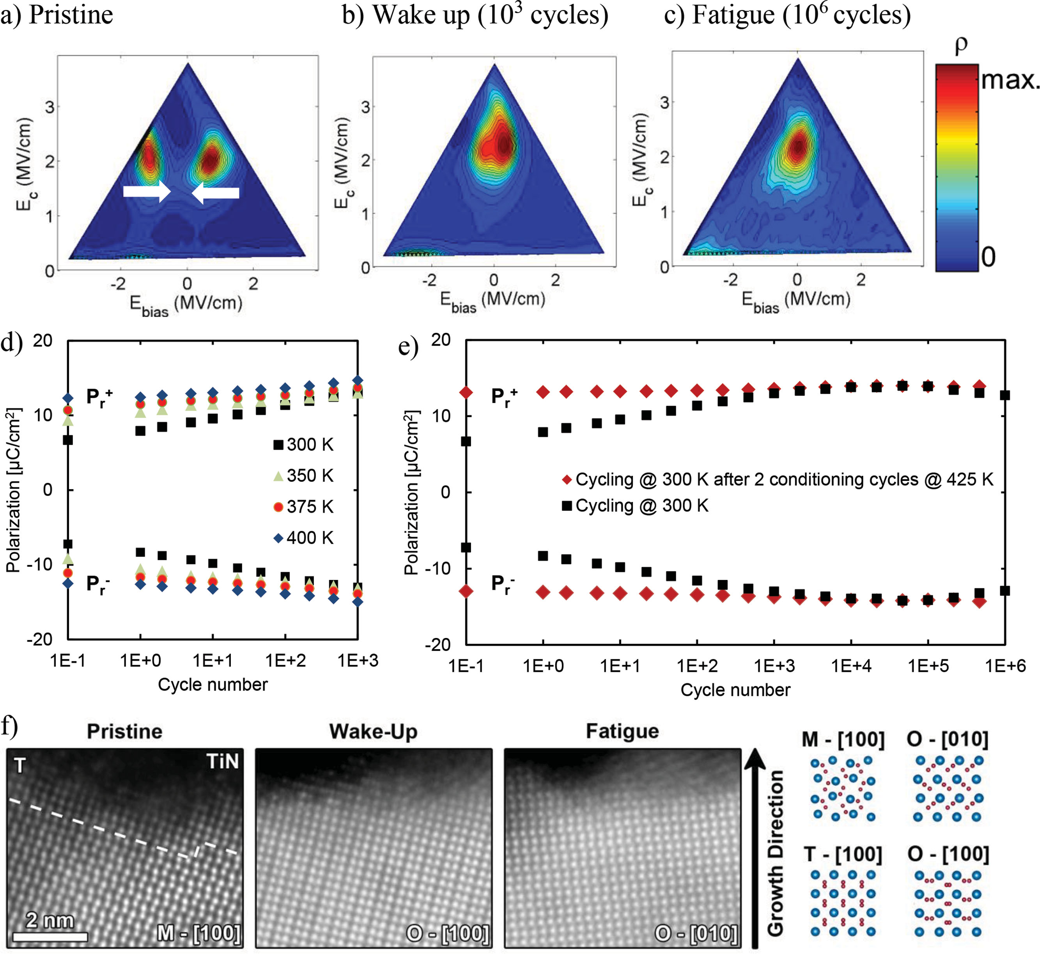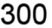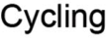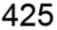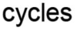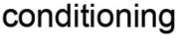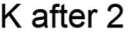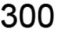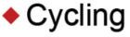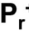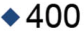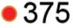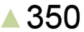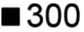

in pristine, wake-up, and fatigue conditions for STEM exami-nation. The structure of this sample is expected to be similar to the electrically tested Sr:HfO 2 . Gd-doped HfO 2 fi lms show analog electrical behavior to the Sr:HfO 2 samples investigated in this work as already reported by Hofmann et al. [ 28 ] A more detailed comparison is presented in the Supporting Informa-tion S2. Monoclinic (paraelectric, PE) and orthorhombic (fer-roelectric, FE) grains were observed in the samples, with decreasing monoclinic presence and increasing orthorhombic presence for samples subjected to greater amounts of fi eld-cycling. Bulk grains adjacent to the electrode interfaces had a tendency to relax toward distorted tetragonal phase symmetry within the last few unit cells of HfO 2 next to the interfaces.

Relaxation at the electrodes toward tetragonal symmetry was observed in samples from all three cycling conditions, though it was most pronounced in the pristine and least pronounced in the fatigued samples. Figure 2 f) shows STEM images of the HfO 2 /electrode interfaces for each cycling condition. The pristine sample exhibits the greatest tendency to relax toward tetragonal symmetry. The wake-up image shows some relaxa-tion toward the interface, but it seems to retain the phase of the bulk grain more than the pristine. The fatigued sample shows little to no relaxation at the interface. Beside the change in the ferroelectric response, observed phase changes should have signifi cant impact on the dielectric constant of the com-plete stack. Therefore, small-signal capacitance measurements

|  |  |  |  |
| --- | --- | --- | --- |
| **4604** | **wileyonlinelibrary.com** | © 2016 WILEY-VCH Verlag GmbH & Co. KGaA, Weinheim | *Adv. Funct.Mater.***2016**, *26*, 4601–4612 |

|  |  |
| --- | --- |
| **www.MaterialsViews.com** | **www.afm-journal.de** |

onset of the fatigue (drop of the polarization) is visible. This is   
accompanied by an increase of the leakage current indicating a   
degradation of the stack, continuation of the phase transition   
and further drop of the total capacitance and k-value as well. 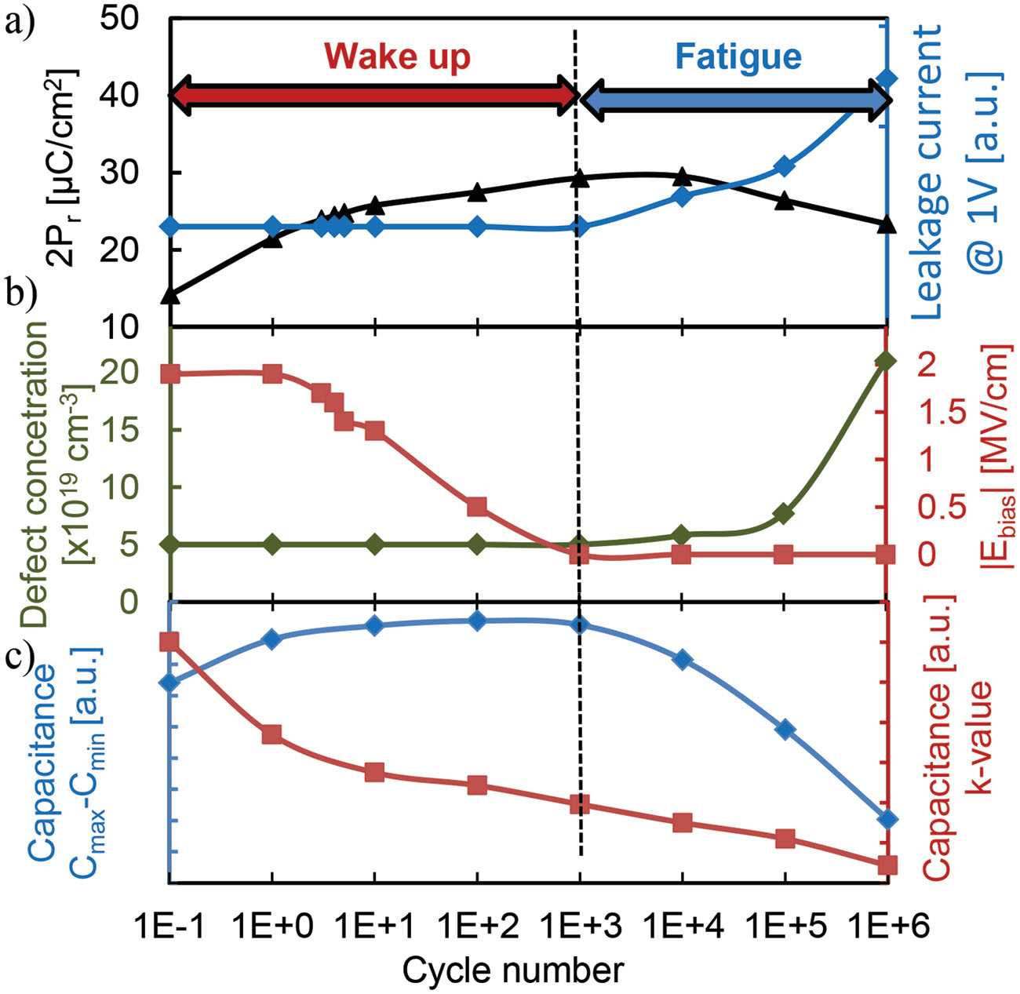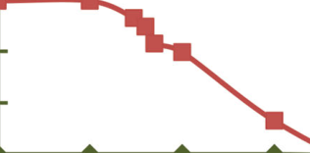

**2.2. Mechanisms**

Mechanisms responsible for the wake-up and fatigue of the   
conventional ferroelectric materials were investigated in detail   
during the past 50 years. A huge number of publications pro-  
posed numerous scenarios dealing with increase and decrease   
of the polarization in perovskite-based materials. Wake-up   
studies on PZT material system were performed and reported   
before. [ 15,29,30 ] On the other hand, a very detailed and system-  
atic review of fatigue mechanisms was reported by Tagantsev   
et al. in 2001 [ 17 ] and Lou et al. in 2009. [ 31 ] These studies sug-  
gested that a combination of several mechanisms (domain de-/   
pinning, [ 32 ] seed inhibition, [ 33 ] and formation of the passive/   
dead layer [ 34 ] ) could be responsible for the device wake-up and   
fatigue. Even though these studies proposed a detailed discus-

**Figure 3.**  a) Evolution of the ferroelectric remnant polarization compared to leakage current during bipolar cycling measured on Sr:HfO 2 -based fer-roelectric capacitors; b) extracted defect concentration and bias fi eld evo-lution as well as c) capacitance cycling behavior.

were performed as function of the external bias voltage ( *C* – *V* ). As for other experiments, capacitance evolution was also recorded during the fi eld cycling. Typical ferroelectric *C* – *V* curves are characterized by butterfl y hystereses with maxima that occur due to the contribution of domain wall capacitance around the coercive fi eld (during the polarization switching). The dielectric constant of complete stack (interfaces and bulk) was extracted from the most saturated region of the character-istics where contributions of the domain wall capacitance are minimal. Independently from the cycling stage, continuous total capacitance/k-value drop of 5% was observed (see Sup-porting Information S3 and **Figure3** c). This behavior indicates that the T→O phase transformation (decrease of the k-value) in the interfacial region has a stronger impact on the total k-value than the M→O transformation (increase of the k-value) that occurs within the bulk. A detailed electrical model consisting of three serial capacitors for the two interfaces *C*IF and the fer-roelectric bulk *C*bulk of the stack is given within the Supporting Information S3. Besides the continuous drop of the k-value, in Figure 3 c can be seen that the amount of the charge within the system (ratio of the peak value- *C*max and saturated capac-itance- *C*min ) completely match with evolution of the remnant polarization.

Combining all electrical results, some trends during the fi eld cycling can be isolated (Figure 3 ): Initially, during the wake-up stage: the polarization response increases, bias fi elds diminish whereas the leakage current stays constant. From the structural perspective, the stressed capacitor undergoes a phase transfor-mation of M→O and T→O in the bulk and interfaces, respec-tively. Both, the increase of the polarization response and the phase transition are accompanied by an increase of the total switching charge within the material system and continuous drop of the capacitance/k-value. With further fi eld cycling, the

sion of the mechanisms, most of the literature only discusses phenomenological scenarios.

In order to properly assess the complex physical inter-play governing the wake-up and degradation mechanisms in **Figure4** , we show a sketch of potential interactions among mechanisms affecting either dielectric (i.e., defect—O vacancy and O ion—creation, diffusion, recombination) and ferro-electric (change of the remnant polarization by, e.g., domain wall pinning, seed inhibition and other modifi cations of the switching process) properties. These mechanisms are con-nected to each other and take place at both interfacial and in bulk regions. Therefore, they cannot be perfectly separated in reality. For instance: the ferroelectric switching degradation might be connected to defect, i.e., O vacancy creation and sub-sequent charge trapping. The defect creation depends on the fi eld, and increases with increasing fi eld due to the switching and ion displacement of the ferroelectric material during cycling. [ 35 ] As it can be seen from Figure 3 , the relation of the mechanisms within the stack is of rather complex nature neces-sitating in-depth studies.

As every high-k material, [ 36 ] Sr:HfO 2 is characterized by a certain amount of oxygen vacancies within the material (see Supporting Information S4 for an estimate). The application of the alternating bipolar cycling voltage represents the main source of stress: It causes the injection of charges into existing vacancies, which can change the polarization state of the ferroe-lectric material via local fi eld modifi cations [ 21 ] as well as domain de-/pinning. This can result in either a rise or a degradation of the remnant polarization. Furthermore, the applied fi eld can either generate new O/Hf vacancies or force the existing ones to diffuse along the material. As a consequence of the vacancy diffusion and generation, a portion of the device volume can undergo a phase transformation. This transformation into a switching or nonswitching phase together with the k-value change can either impede or facilitate the ferroelectric response by changing the internal bias fi eld. In the following, these mechanisms will be assessed in detail, using a special series of experiments and modeling approaches.

|  |  |  |  |
| --- | --- | --- | --- |
| *Adv. Funct. Mater.***2016**, *26*, 4601–4612 | © 2016 WILEY-VCH Verlag GmbH & Co. KGaA, Weinheim | **wileyonlinelibrary.com** | **4605** |

|  |  |  |
| --- | --- | --- |
| **FULL PAPER** | **www.afm-journal.de** | **www.MaterialsViews.com** |
| considered. These interfacial regions consist of nonswitching |
| transitional material (TM-HfO 2 ) ( **Figure5** ) and are parasitically |
| grown during the deposition of the HfO *x*and the subsequent |
| annealing step. [ 39,40 ] During deposition of the HfO 2 dielec- |
| tric atop of TiN bottom electrode, a TiO x N y interfacial layer is |
| formed, which pulls oxygen out of the HfO 2 whereas nitrogen |
| diffuses into the dielectric. [ 39,40 ] Moreover, an additional growth |
| of the bottom interface layer was reported during top electrode |

deposition, [ 39,40 ] which creates further asymmetry within the   
device. Studies by Park et al. even suggest a partial oxidation   
of the complete TiN. [ 41,42 ] Thus, the complete device stack con-  
sists of TiO x N y /TM-HfO x /FE-HfO 2 /TM-HfO x /TiO x sandwiched   
between two TiN electrodes, Figure 5 b. Polycrystallinity of   
the HfO 2 layer was explicitly taken into account, creating the   
grain structure of the stack, as shown in Figure 5 b. As men-  
tioned above, Sr doped HfO 2 was crystallized using a 800 °C   
anneal in nitrogen atmosphere. The ferroelectric layer within   
the device is polycrystalline and has a granular structure with   
slightly varying properties. Therefore, the hafnia ferroelec-  
tric layer is divided into randomly distributed grains and two   
interface layers next to the electrodes. The granular struc-  
ture and grain boundaries are very important since they are   
known to be the preferable locations for the accumulation of 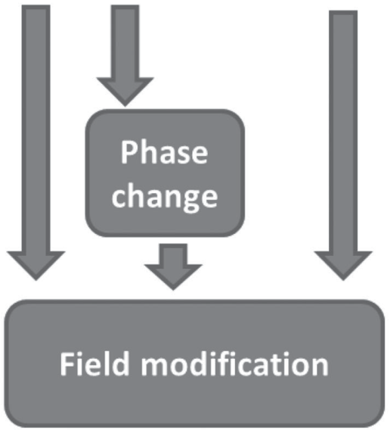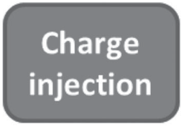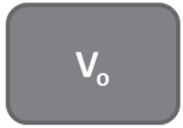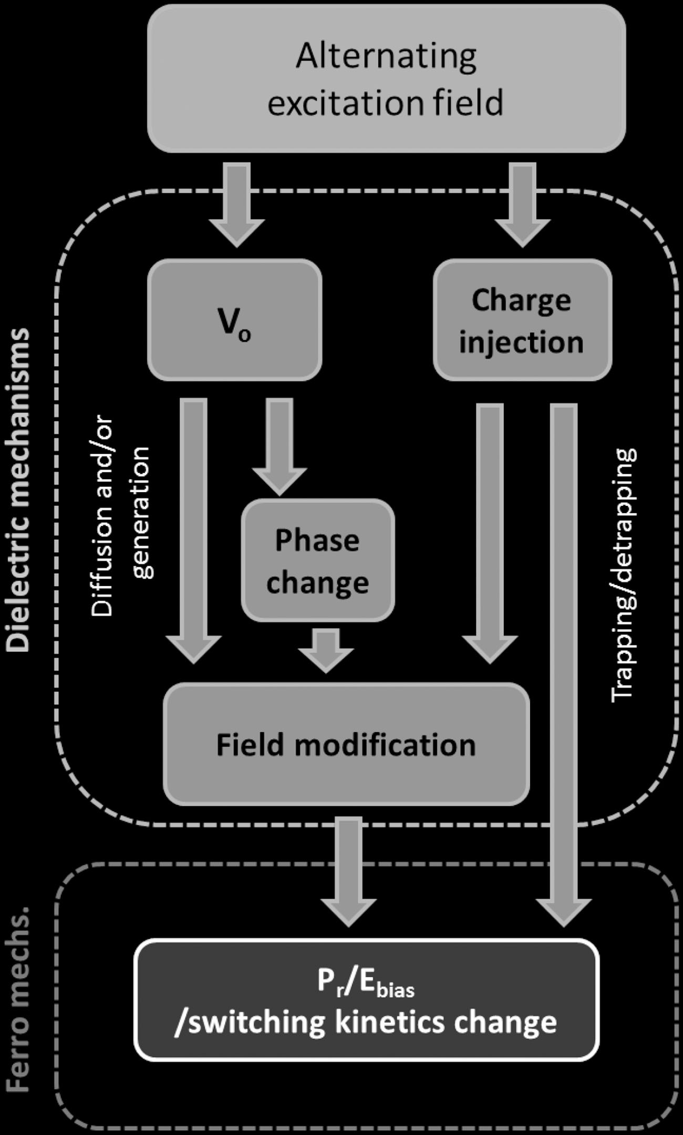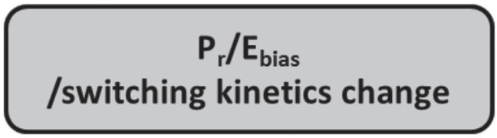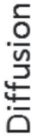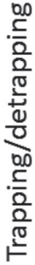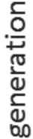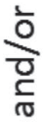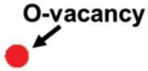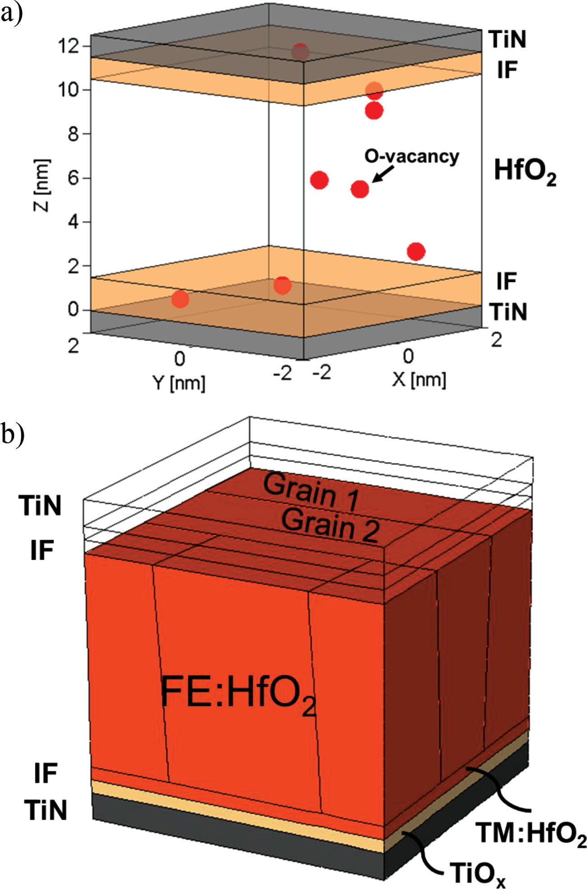

**Figure 4.**  Flow chart of the device lifetime mechanisms. In the red box,   
external excitation is given; the blue boxes depict mechanisms that result   
from this external stimulus and affect the dielectric properties. These   
mechanisms cause two separate processes which promote or counteract   
the effective ferroelectric properties of the fi lm stack (green box).

**3. Modeling**

In this section, we will investigate the two cycling stages,   
e.g., wake-up and fatigue, using a comprehensive modeling   
approach. This approach relies on a combination of a dielec-  
tric-based simulation software [ 37 ] and a commercial TCAD Sen-  
taurus device simulator [ 38 ] tool.

In order to solidify the assumption and unveil the observed   
behavior, we developed a modeling framework, which allows a   
better understanding of the correlation between ferroelectric   
and dielectric properties of the material. The modeling frame-  
work combines the MDLab software, used to investigate the   
leakage current and O vacancy defect creation and diffusion, [ 37 ]   
with the TCAD Sentaurus device simulator, which was used to   
investigate the ferroelectric properties of the stack.

To accurately account for the real characteristics of the MIM

device, the impact of the two interfacial regions on the elec-trical behavior of the TiN/Sr:HfO 2 /TiN capacitor has to be

**Figure 5.**  a) 3D device compact model developed by MDLab; b) 3D TCAD model.

|  |  |  |  |
| --- | --- | --- | --- |
| **4606** | **wileyonlinelibrary.com** | © 2016 WILEY-VCH Verlag GmbH & Co. KGaA, Weinheim | *Adv. Funct.Mater.***2016**, *26*, 4601–4612 |

|  |  |
| --- | --- |
| **www.MaterialsViews.com**  the oxygen vacancies. These oxygen vacancies, in turn, assist the trap-assisted current and are responsible for the local fi eld modifi cations due to charge trapping. Moreover, defect states were coupled to the neighboring electrodes by a nonlocal tun-neling mechanism. This tunneling model is available within the Sentaurus Device simulator of Synopsis TCAD and unifi es a direct, a Fowler-Nordheim and a TAT mechanism, as well as multiphonon emission. [ 43 ]  Finally, to reproduce the real behavior of the stack, we accounted for different phases of the doped hafnia, which can coexist inside the same grain: (1) the orthorhombic phase, responsible for the ferroelectric switching; (2) monoclinic and (3) tetragonal phases, which are not active from the ferroelectric | **www.afm-journal.de**  to PZT. [ 18 ] Furthermore, a recent transmission electron micro-scopy study confi rmed the generation and movement of oxygen ions and vacancies within 10 nm thick HfO 2 fi lm under similar operating conditions. [ 46 ] Starschich et al. just recently proved resistive and ferroelectric switching operation in one and the same Y:HfO 2 -based device. [ 47 ]  Moreover, not every defect has the energetic and spatial properties to be activated in electron transport or ferroelec-tric switching on other side. Thus, the extracted numbers are expected to be slightly lower than those estimated from the dopant content and the deposition process itself (see Sup-porting Information S4). In order to examine the cycling infl u-ence and dynamics within the stack as well as its infl uence |
| point of view. | on the fi eld distribution (predominantly on built-in fi elds), we |



For calibration purposes, the leakage currents measured at different temperatures [ 35 ] on the pristine ferroelectric capacitor were simulated using the multiphonon TAT transport model implemented in the MDLab package. [ 37,44 ] An initial density of O vacancy defects of 5 × 10 19 cm −3 with a defect thermal ionization energy of 2.1 ± 1.1 eV below the conduction band was extracted, which has been used for the subsequent mod-eling and investigation. Detailed transport mechanism and dominating trap-assisted-tunneling within the HfO 2 based dielectric were previously reported elsewhere. [ 43–45 ] Besides the vacancies, that actively assist the electron TAT current, [ 44 ] interstitial oxygen ions were considered within the stack. These oxygen vacancies and ions were created by doping the HfO 2 material with Sr as well as by pulling oxygen out of the hafnia during the top electrode deposition process and annealing step. The extracted defect distributions were fed into the 3D grain boundary model of the FeCap developed within the Sentaurus device simulator to simulate the ferroelectric response.

simulated the diffusion and recombination of oxygen ions and vacancies through a kinetic Monte Carlo model implemented in the MDLab package. [ 37 ] Diffusion rates are calculated by considering activation energy for ion and vacancy diffusion of 0.7 and 1.1 eV, respectively. [ 46,48,49 ]  
 In the pristine state, we consider that the transitional regions at the dielectric interface have a much higher defect density. This is mainly due to the material intermixing that leads to the formation of a thin ≈1 nm thick substoichiometric TiO *x*regions, which represent oxidized TiN and does not signifi cantly affect the overall k-value of the stack. Accordingly, the k-value of TiO *x* has to be similar or slightly lower than that of HfO 2 . Besides the lower k-value, such interfacial regions are characterized by a large defect density (mainly O vacancies). These, low-k TiO x regions are accompanied by a rough 1.5 ± 1 nm thick HfO 2 interface predominantly with a higher k-value due to the pres-ence of a tetragonal phase as seen it Figure 2 f. These two fac-tors signifi cantly affect the voltage distribution inside the die-lectric layer: The superposition of the lower dielectric constant and the electron trapping at interfacial defects can results in

**3.1. Wake-Up**  local increase/decrease of the fi eld, which affects the resulting

polarization of the ferroelectric layer.

As discussed before, the wake-up effect is attributed to the gradual decrease of the built-in bias fi eld. These could be due to the O vacancy defect redistribution that can change their charge state, and/or partial phase transition and k-value change within

The initial scenario of different biased regions and the so-called built-in fi elds was created by preferentially highest density of the vacancies in the interfacial regions ( **Figure6** ). Furthermore, the same scenario was used to simulate the pref-

the layer. erable movement of the vacancies driven by the applied electric

The same model was also used for the simulation of the leakage current evolution with cycling (see Figure 1 c), which allows extracting the increase in the density of O vacancy defects within the stack. The increase of density of the oxygen vacancy defects seems correlated with the *P*r evolution observed with cycling, Figure 3 b. However, it should be noted that the density of defects evaluated from the leakage current corre-sponds mainly to those located at the grain boundaries, where they contribute the most to the leakage current. [ 45 ] Namely, the leakage current thought the grain boundaries is more than tenfold higher than through the grain itself. Thus, the diffu-sion of the vacancies thought the grain would keep the leakage current constant during the wake-up stage. The role of O vacancy/ion diffusion is also consistent to the fact that HfO 2 based devices are known for their high oxygen mobility. [ 18 ] This claim becomes even more strengthened by the fact that the electric fi eld applied on the HfO 2 -based ferroelectrics is at least one order of magnitude higher than that, typically applied

fi eld. In order to investigate the physics of the wake-up process, bipolar cycling stress simulations were performed using the MDLab simulation package, which allows the description of charge and ionic transport. As shown in the Figure 6 a–c, the O vacancies redistribute uniformly within the grain. Moreover, besides this drift/diffusion process, a recombination of vacan-cies and interstitial ions can also occur. As a consequence, the built-in bias fi eld decreases. A more uniform fi eld distribution is created within the stack, resulting in a uniform switching of all domains within the device (see Figure 6 d–f). An increase of the temperature kinetically accelerates the vacancy diffusion resulting in more mobile vacancies and faster wake-up, which is in agreement to Figure 2 e. In order to confi rm the infl uence of the temperature observed in the wake-up characterization on elevated temperatures, the simulation was repeated at 150 °C. The uniform fi eld distribution was achieved two orders of mag-nitude faster than in the room temperature case, which cor-responds to the experimental results shown in Figure 2 f: 10 3

|  |  |  |  |
| --- | --- | --- | --- |
| *Adv. Funct. Mater.***2016**, *26*, 4601–4612 | © 2016 WILEY-VCH Verlag GmbH & Co. KGaA, Weinheim | **wileyonlinelibrary.com** | **4607** |

|  |  |  |
| --- | --- | --- |
| **FULL PAPER** | **www.afm-journal.de** | **www.MaterialsViews.com** |

**Figure 6.**  Simulated wake-up of the device: a) vacancy diffusion and b) corresponding electric fi eld evolution within the device with the fi eld cycling of the FeCap in three different points in time at 4 MV cm −1 external applied fi eld. IF represents a low-k interfacial layer whereas G1–G3 represent three different grains within the stack. c) Resulting *I* – *V* and *P* – *V* characteristics obtained by removing the charges from the interface and changing the k-value of the grains undergoing the phase transformation.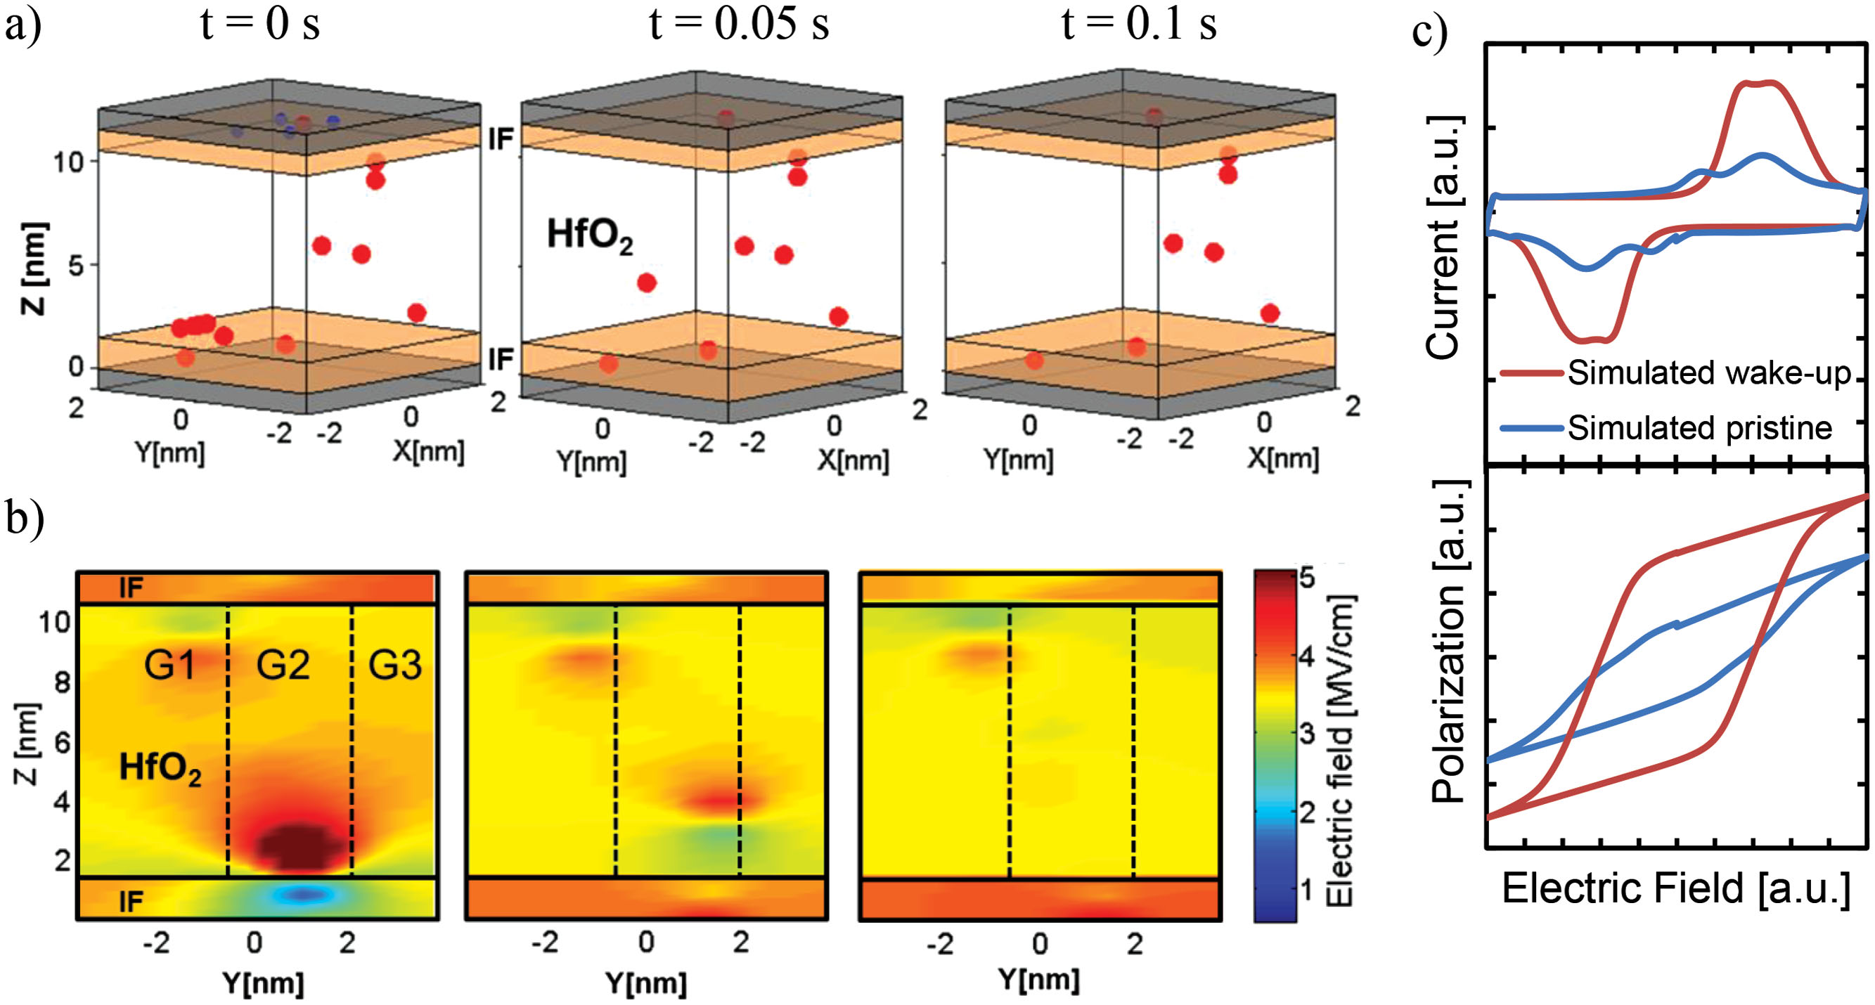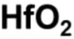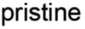

cycles at RT, 2 cycles at 150 °C. Besides the more uniform fi eld distribution due to vacancy diffusion, the movement of ions possibly can cause the phase transformation. As reported by Hoffmann et al. [ 50 ] dopants stabilize the ferroelectric phase, i.e., decrease its formation energy compared to the monoclinic ref-erence phase. This is confi rmed also by TEM results that show the transition of the initially tetragonal phase of nonswitching TM-HfO 2 interface to orthorhombic phase (switching) for the woken up device. A thickness reduction of this dead layer [ 34 ] on the interface decreases the infl uence of the parasitic voltage divider and increases the ferroelectric switching response of the device. Thus, the remnant polarization increases during the wake-up. Although the vacancies move toward the middle of the device, the leakage current stays constant because it is dominated by the leakage through the grain boundaries and not through the grain volume. Therefore, vacancies that move during the wake up phase, indeed increase the leakage current component through the grains however insignifi cantly to be seen in the total current. Moreover, the observed phase tran-sition (M → O phase) increases the k-value of the stack. This reduces the fi eld driven leakage transport mechanisms coun-teracting the aforementioned negligible increase of the leakage component via the grain volume.

In parallel to the compact modeling of the diffusion pro-cesses and evolution of the fi eld distribution within the device, a ferroelectric switching modeling is needed to compare the charge and fi eld infl uence on the switching of the device.

Accordingly, a 3D ferroelectric capacitor model was set-up in Synopsys TCAD Structure Editor. [ 38 ] The model is illustrated in

To model the ferroelectric behavior a physical model accounting for the history dependence of ferroelectric devices is required. In case of a ferroelectric capacitor the charge-voltage relationship is nonlinear and represents a second term of the dielectric displacement vector (see Supporting Information S5 for details). This complex behavior is very similar to the Prei-sach hysteresis model, which is used for ferromagnetic and fer-roelectric materials [ 51 ] and it is implemented within Sentaurus Device. [ 38 ] Properties of the modeled ferroelectric material can be found in the Supporting Information S6, where the para-meters are tuned in order to obtain the desired characteristics.

Every measured capacitor consists of thousands of grains, [ 50 ] which all might have a slight different domain orientation, coercive fi eld or remnant polarization. To address the vari-ability in the resulting switching characteristics, each of the modelled grains represents an averaged ensemble of domains and grains with similar properties, which are defi ned by a distinct coercive fi eld and remnant polarization value. Coer-cive fi elds used within the grains were chosen in the range of 1.6–2.9 MV cm −1 which is in accordance to the coercive fi eld distribution obtained by FORC measurements (see Supporting Information S1). Moreover, the remnant polarization of the grains was distributed between the 15 and 24 µC cm −2 . Finally, a nonlocal mesh is constructed in order to calculate the tun-neling currents and to couple the traps with the electrodes.

The initial stack is also affected by the presence of defects, whose charge can unpredictably alter the local fi eld, affecting the ferroelectric switching performances. To account for this effect, it was considered that oxygen vacancies are preferentially

|  |  |  |  |
| --- | --- | --- | --- |
| **4608** | Figure 5 b. | distributed at the interfacial regions. These regions are mainly | |
| **wileyonlinelibrary.com** | © 2016 WILEY-VCH Verlag GmbH & Co. KGaA, Weinheim | *Adv. Funct.Mater.***2016**, *26*, 4601–4612 |

|  |  |
| --- | --- |
| **www.MaterialsViews.com**  made of tetragonal phase HfO x , with higher permittivity, which in turn affects also the local fi eld.  Moreover, these regions are considered nonswitching in the pristine, i.e., they act as a passive (dead) layer. [ 34 ] Fur-thermore, monoclinic (nonswitching phase) was modeled setting the grains to a low-k nonswitching state. Using the Preisach model implemented in Sentaurus device simu-lator, a double peak *I* – *V* characteristic as well as a pinched hysteresis loop was successfully simulated (see Figure 6 c). Domain de-pinning was represented through the removal of the charges within the interface whereas the phase transfor-mation was included by changing of the respective k-values and setting the portions of interface as well as the previously | **www.afm-journal.de**  the infl uence of the trapping and stack degradation (see Figure 7 b). After the completion of the endurance test, a second endurance experiment was performed. The waiting time between the two endurance measurements was varied. Several devices were stressed with 10 9 bipolar cycles. After-ward, each of them was stressed again with the same amount of cycles with sequentially increasing waiting time. In the fi rst experiment immediately after the fi rst run, a second endurance test was recorded. In order to ensure the same initial condition after the initial cycling, the next already pre-conditioned device was stressed after a sequentially increased waiting time. As suggested by modeling and experiments performed before, trapping and degradation had a strong |



nonswitching grains to switching state. These modifi cations result in a merging of the peaks and the opening of the hys-teresis curve (see Figure 6 c) which completely emulates the

infl uence on the ferroelectric behavior and memory charac-teristic of the ferroelectric capacitor device. With increasing waiting time, stronger recovery of the remnant polariza-

mea sured device behavior. tion was observed. This behavior inevitably coincides with progressive de-trapping of electrons from occupied defects.

The longer the waiting time, more defects were de-trapped,  **3.2. Fatigue**  resulting in domain de-pinning and consequent recovery of the polarization state. In addition, an earlier onset of the

Having detailedly discussed the effects dominating the so-called wake-up, which lead to an enhancement of the ferroelec-tric properties during the initial cycles, the subsequent gradual degradation of these properties is studied.

As shown in Figures 1 c and 3 b, there is a direct correla-tion between the increase of the defect concentration and the degradation of the MW. Using the thermochemical bond breakage model implemented in the MDLab software, [ 37,44,52 ] it was found that a faster O vacancy defect generation occurs at the TiO x interface toward the electrodes. These low quality, nonswitching regions are characterized by more defects and a lower permittivity, resulting in a higher factor of degradation and faster bond breakage. The defect generation and the sub-sequent charge trapping infl uence the fi eld distribution over the device stack. The fi eld over the interface increases, while it reduces inside the ferroelectric bulk. [ 35 ] Thus, the ferroelec-tric layer experiences a lower switching fi eld, which leads to a reduced number of switching domains if the coercive fi eld of some domains is not reached anymore. Furthermore, charge trapping creates dipoles impeding the switching of the domains, which results in a partial or even complete pin-ning of the domains. All this effects cause a decrease of the memory window. Besides that, the vacancy generation and dif-fusion through the grains continue. In contrast to the wake-up phase, the continued cycling is not only characterized by vacancies diffusion, but also by a vacancy generation within the grains. These defect sites, fi nally, start representing sig-nifi cant leakage current path besides previously dominating leakage through the grain boundaries. To further verify that

degradation was seen for all devices independently of the waiting time. This confi rms the previously discussed degra-dation of the layer. Accordingly, the 3D ferroelectric TCAD capacitor model described above (Figure 5 b) was used for the simulation of the resulting ferroelectric switching response. The model implemented within Sentaurus Device [ 38 ] veri-fi ed the degrading infl uence on the fi eld distribution over the stack and the resulting current voltage and polariza-tion voltage characteristic (Figure 7 c,d). Charge injection and subsequent charge trapping reduce the fi eld across the stack. Moreover, trapped charge within the bulk of the device reduces the amount of domains participating in switching (domain pinning) and results in a decrease of the polariza-tion. The memory window closes, i.e., the 2 *P*r margin drops (Figure 7 c,d).

As discussed in section 2 , two stages of the capacitor life-time can be isolated, wake-up and fatigue. Finally, the combi-nation of the results of both extensive electrical characteriza-tion and modeling are shown in **Figure8** . It was found that mechanism behind the wake-up behavior are material and charge drift/diffusion due to the alternating fi eld cycling as well as structural changes of the material (T→O and M→O phase transition) in a fi rst regime. Second, the mechanism responsible for fatigue and degradation of the ferroelectric occurs parallel to the drift/diffusion processes and starts to dominate at higher numbers of switching cycles (Figure 8 d). The generation of new defects (oxygen vacancies) and the injection of charges modify the switching properties of the device causing the pinning of the domains and consequent

|  |  |
| --- | --- |
| the O vacancy defect generation is the root cause for the memory window degradation, temperature dependent endur- | reduction of the *P*r . |

ance measurements were performed ( **Figure7** a). The evolu-

|  |  |
| --- | --- |
| tion of *P*r with the number of switching cycles at elevated tem-peratures showed an earlier onset as well as an increase of the | **4. Conclusion** |

absolute slope (enhanced fatigue) with increasing temperature (Figure 7 a).

Besides the degradation at elevated temperatures, recovery experiments were performed in order to fully assess

In conclusion, the mechanisms responsible for the fi eld cycling behavior of HfO 2 -based ferroelectric capacitors were studied. Within the lifetime of the device two main regimes of wake-up and fatigue were identifi ed and examined. In

|  |  |  |  |
| --- | --- | --- | --- |
| *Adv. Funct. Mater.***2016**, *26*, 4601–4612 | © 2016 WILEY-VCH Verlag GmbH & Co. KGaA, Weinheim | **wileyonlinelibrary.com** | **4609** |

|  |  |  |
| --- | --- | --- |
| **FULL PAPER** | **www.afm-journal.de** | **www.MaterialsViews.com** |
| the fi rst part wake-up effects were studied |
| by intensive electrical characterization of |
| built-in bias fi elds, which were shown to |
| be responsible for the two switching peaks |
| observed for the pristine device. A com- |
| bination of comprehensive ferroelectric |
| switching current experiments at elevated |
| temperatures, Preisach density analysis |

(FORC plots), trap defect spectroscopy   
method, and modeling of the leakage cur-  
rent was used to identify that no defects   
are generated but rather existing defects   
are redistributed within the device during   
the wake-up. The faster diminishing of   
the built-in fi eld at elevated temperatures   
solidifi ed the assumption that the removal   
of built-in fi eld, i.e., the creation of the uni-  
form fi eld distribution, during the wake-up   
was diffusion and drift driven. In addition,   
a comprehensive TEM study suggested a   
phase transition of the interface regions   
during cycling. Moreover, it also revealed   
the phase transformation of predominantly   
pristine M-phase to woken-up O-phase in   
the bulk of the fi lm. These results motivated   
comprehensive modeling of the vacancies 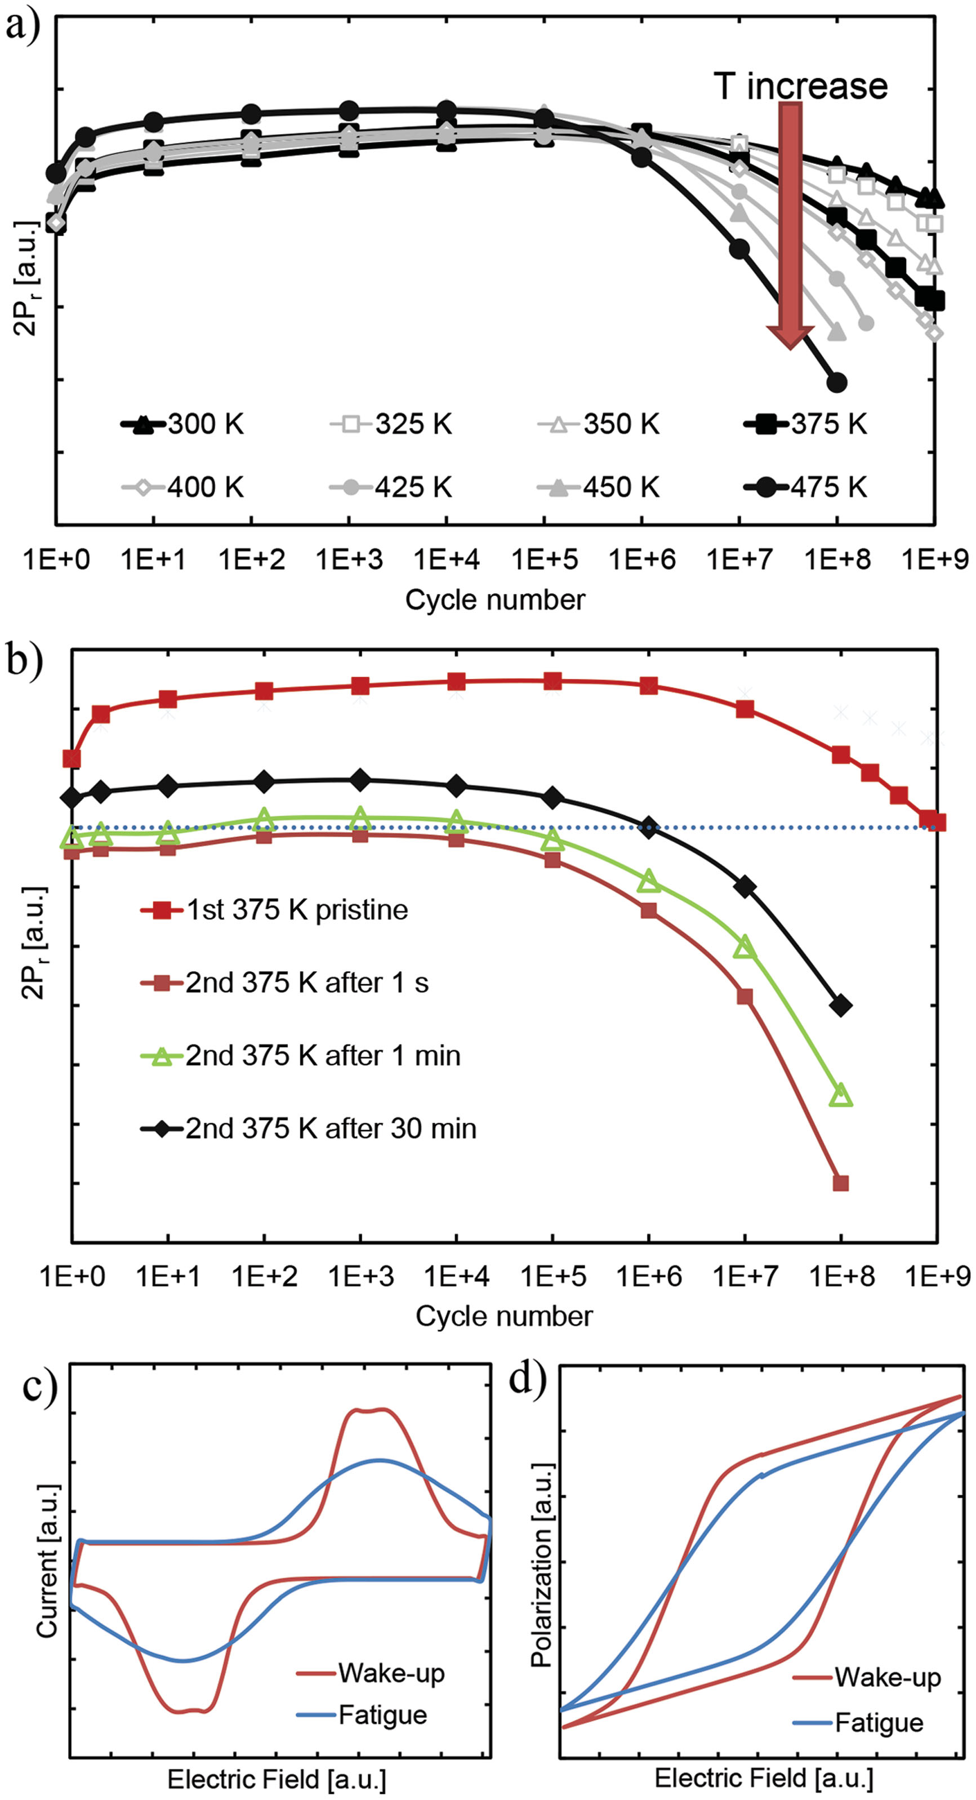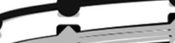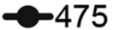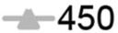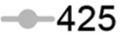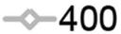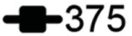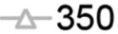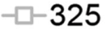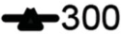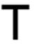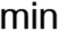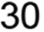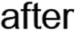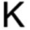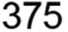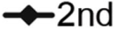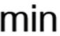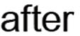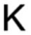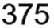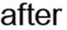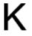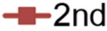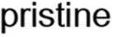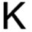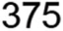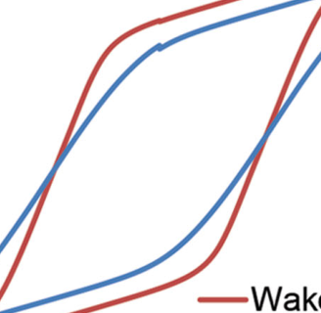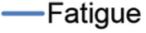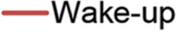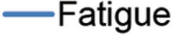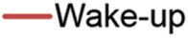

 and ion movement as well as their recom- bination within the stack. By combining the

|  |  |
| --- | --- |
|  | modeling of the diffusion mechanisms and phase transition it was shown that both are |

responsible for: (i) the disappearance of the   
built-in fi eld, (ii) the creation of the more   
uniform fi eld within the device stack, and   
(iii) the consequent increase of the volume   
fraction taking part in switching process.   
Modeling of the ferroelectric behavior by   
means of TCAD Sentaurus Device matched   
the measured ferroelectric behavior.

Furthermore, this study identifi ed the root   
cause of the limited endurance of the doped   
HfO 2 -based ferroelectric capacitors. The die-  
lectric degradation reduces the ferroelectric   
switching. The increase of the trap density   
with device cycling demonstrates that the   
main mechanism responsible for the degra-  
dation of the ferroelectric behavior besides   
domain pinning is the trap generation. It   
takes place within the interfacial regions   
close to the electrodes as well as within the   
bulk. Electron trapping at these defects   
affects the fi eld distribution within the stack   
reducing the fi eld in the bulk of the ferroelec-

|  |  |  |  |  |  |  |
| --- | --- | --- | --- | --- | --- | --- |
| **4610** | **Figure 7.**  a) Memory window evolution as function of device cycling and temperature. Increased temperature results in an earlier fatigue onset. Higher *P*r values were extracted with increasing temperatures due to the parasitic leakage current increase which affects the 2 *P*r extraction procedure; b) polarization recovery obtained (after the initially recorded endurance sequence of 10 9 ) for three different waiting times indicating the infl uence of the de-trapping and relaxation | | tric layer. A further generation of vacancies creates leakage paths, fi nally resulting in a breakdown of the stack before the memory window closes completely.  As a result, optimizations of a capacitor | | | |
| processes. Simulated degradation of c) *I* – *V* and d) corresponding *P* – *V* characteristics. | | based | ferroelectric | memory | fabrication |
| **wileyonlinelibrary.com** | © 2016 WILEY-VCH Verlag GmbH & Co. KGaA, Weinheim | | *Adv. Funct.Mater.***2016**, *26*, 4601–4612 | | |

|  |  |
| --- | --- |
| **www.MaterialsViews.com** | **www.afm-journal.de** |

by improved fabrication processes and   
improving the interface quality to achieve   
only one distinct maximum in the switching   
density, without internal bias fi elds. The   
present study provides some insight into the   
acting mechanism to be addressed in the   
optimization efforts. 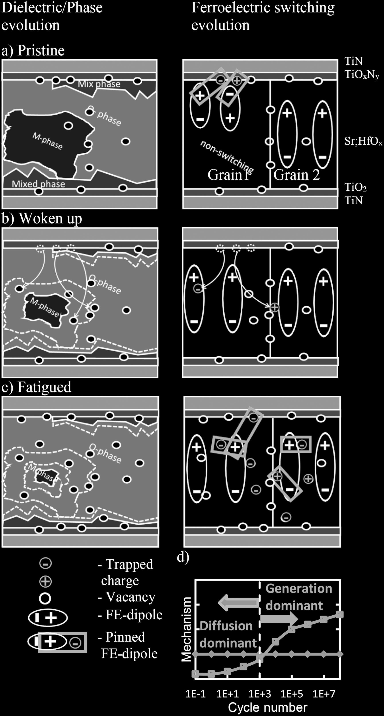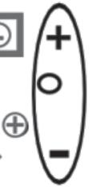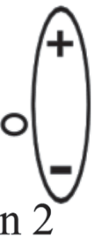



**4. Experimental Section**

The TiN/Sr:HfO 2 /TiN MFM stacks were fabricated   
on Si substrates. A 10 nm TiN bottom electrode   
and the 10 nm Sr:HfO 2 dielectric were deposited   
by reactive sputtering at room temperature and   
atomic layer deposition at 300 °C, respectively.   
The Sr dopant content was determined as reported   
earlier. [ 19 ] Further sample preparation included the   
reactive sputtering of the 12 nm TiN top electrodes   
at 200 °C. After completion of the stack, Sr doped   
HfO 2 was crystalized with a 20 s anneal at 800 °C   
in a nitrogen atmosphere. Finally, dots consisting   
of 10 nm Ti (adhesion layer) and 50 nm Pt on top   
were deposited in an electron beam evaporator   
using a shadow mask defi ning the size of device   
of 9500 µm 2 . Electrical characterization of the   
capacitors was performed using a semiautomatic   
probe station from Cascade Microtech and an   
Agilent B1500A semiconductor device parameter   
analyzer and aixACCT TF 3000 analyzer. The   
dynamic hysteresis curves were measured at the   
frequency of 10 kHz. FORC sweeps were measured   
with the help of Keithley 4200 SCS equipped by   
internal pulse-measure unit. Displacement current   
was monitored as a voltage drop over the 50 Ω   
resistor. 30 nm thick Gd:HfO 2 MFM stacks were   
prepared for STEM using a focused ion beam (FEI   
Quanta) with fi nal thinning at 2 kV. STEM was   
conducted with a probe-corrected FEI Titan G2   
60–300 kV operated at 200 kV with a beam current   
of ≈80 pA, a probe semi-convergence angle of   
≈19.6 mrad, and an HAADF detector inner semi-  
angle of ≈77 mrad. Images were acquired using the   
RevSTEM technique to remove drift distortion. [ 53 ]   
Acquisition involved averaging of ≈40 frames   
sized 1024 × 1024 pixels with 90° rotation between   
frames and a 2 µs dwell time. Images with   
excessive distortion were removed manually after   
drift correction before frame averaging.

**Supporting Information**

Supporting Information is available from the Wiley   
Online Library or from the author.

**Acknowledgements**

|  |  |  |  |  |  |  |  |  |  |
| --- | --- | --- | --- | --- | --- | --- | --- | --- | --- |
| **Figure 8.**  Model of the three different stages of the FeCap lifetime a) pristine, b) wake-up, and c) fatigued; d) evolution of the dominating mechanism. | | | Mihaela Popovici from Imec, Belgium is gratefully acknowledged for the deposition of the TiN/ Sr:HfO 2 /TiN stacks. Michael Hoffmann is gratefully | | | | | | **4611** |
| conditions are needed to achieve stable, low voltage operating conditions with desired *P*r and highest possible endurance. | | acknowledged | | for | the | development | of | the |
| FORC evaluation environment. M.P., St.S., U.S., and T.M. gratefully acknowledge support by the European Fund for Regional Development | | | | | | |
| Solution to that optimization problem can only be provided | | and the Free State of Saxony. T.S. was supported by the Deutsche | | | | | | |
| *Adv. Funct. Mater.***2016**, *26*, 4601–4612 | © 2016 WILEY-VCH Verlag GmbH & Co. KGaA, Weinheim | | | **wileyonlinelibrary.com** | | | | |

|  |  |  |
| --- | --- | --- |
| **FULL PAPER** | **www.afm-journal.de** | **www.MaterialsViews.com** |
| Forschungsgemeinschaft (DFG project: Inferox). E.D.G., X.S., and J.M.L. | [22] C. R. Pike , A. P. Roberts , K. L. Verosub , *J. Appl. Phys.* **1999** , *85* , 6660 . |
| gratefully acknowledge support from the National Science Foundation | [23] L. Cima , E. Laboure , P. Muralt , *Rev. Sci. Instrum.* **2002** , *73* , 3546 . |
| (DMR-1350273) and the use of the Analytical Instrumentation Facility at | [24] L. Mitoseriu , L. Stoleriu , A. Stancu , C. Galassi , V. Buscaglia , *Process.* |
| North Carolina State University, which is supported by the state of North |
| *Appl. Ceram.* **2009** , *3* , 3 . |
| Carolina and the National Science Foundation. E.D.G. was supported | [25] A. L. Shluger , K. P. McKenna , in *2013 IEEE Int. Reliability Physics* |
| by the National Science Foundation through a Graduate Research |
| *Symposium (IRPS)* , IEEE , Anaheim, CA  **2013** , 5A – 1 -. |
| Fellowship (DGE-1252376). |
| [26] S. R. Bradley , A. L. Shluger , G. Bersuker , *Phys. Rev. Appl.* **2015** , *4* , |
| Received: February 2, 2016 | 064008 . |
| [27] E. D. Grimley , T. Schenk , X. Sang , M. Pešic´ , U. Schroeder , |
| Revised: March 1, 2016 |
| J. M. LeBeau , unpublished. |
| Published online: May 6, 2016 |
| [28] M. Hoffmann , T. Schenk , I. Kulemanov , C. Adelmann , M. Popovici , |

U. Schroeder , T. Mikolajick , *Ferroelectrics* **2015** , *480* , 16 . 

[29] M. I. Morozov , D. Damjanovic , *J. Appl. Phys.* **2008** , *104* , 034107 .

[1] T. S. Böscke , J. Müller , D. Bräuhaus , U. Schröder , U. Böttger , *Appl.*  [30] V. Y. Shur , I. S. Baturin , E. L. Rumyantsev , *Ferroelectrics* **2007** , *349* , *Phys. Lett.* **2011** , *99* , 102903 . 163 .

[2] U. Schroeder , E. Yurchuk , J. Mü ller , D. Martin , T. Polakowski , P. Schenk , C. Adelmann , M. I. Popovici , S. V. Kalinin , T. Mikolajick , *Jpn. J. Appl. Phys.* **2014** , *53* , 08LE02 .

[3] J. Mü ller , T. S. Bö scke , U. Schrö der , S. Mueller , D. Brä uhaus , U. Bö ttger , L. Frey , T. Mikolajick , *Nano Lett.* **2012** , *12* , 4318 .

[4] P. Polakowski , J. Müller , *Appl. Phy. Lett.* **2015** , *106* , 232905 .

[31] X. J. Lou , *J. Appl. Phys.* **2009** , *105* , 024101 .

[32] W. L. Warren , D. Dimos , B. A. Tuttle , G. E. Pike , R. W. Schwartz , P. J. Clews , D. C. McIntyre , *J. Appl. Phys.* **1995** , *77* , 6695 .

[33] E. L. Colla , S. Hong , D. V. Taylor , A. K. Tagantsev , N. Setter , K. No , *Appl. Phy. Lett.* **1998** , *72* , 2763 .

[34] A. K. Tagantsev , M. Landivar , E. Colla , N. Setter , *J. Appl. Phys.* **1995** ,

[5] J. L. Moll , *IEEE Trans. Electron Devices* **1963** , *ED-10* , 338 . *78* , 2623 .

[6] T. P. Ma , J. P. Han , *IEEE Electron Device Lett.* **2002** , *23* , 386 .

[7] T. Mikolajick , S. Müller , J. Müller , *Adv. Sci. Technol.* **2014** , *95* , 136 . [8] S. Mueller , E. Yurchuk , S. Slesazeck , T. Mikolajick , J. Muller , T. Herrmann , A. Zaka , in *IEEE Int. Symp. Appl. Ferroelectr. Workshop*  *Piezoresponse Force Microscopy (ISAF/PFM)* , IEEE , Prague  **2013** , 248 .

[35] M. Pešic´ , F. P. G. Fengler , S. Slesazeck , L. Larcher , A. Padovani , U. Schröder , T. Mikolajick , *Root cause of degradation in novel HfO 2 -based Ferroelectric Memories* , IEEE IRPS April 2016 , in press.

[36] P. McIntyre , *ECS Trans.* **2007** , *11* , 235 .

[37] *MDLab virtual laboratory software package* , http://www.mdlab-soft-

[9] J. Müller , E. Yurchuk , T. Schlösser , J. Paul , R. Hoffmann , ware.com/

S. Müller , D. Martin , S. Slesazeck , P. Polakowski , J. Sundqvist , M. Czernohorsky , K. Seidel , P. Kücher , R. Boschke , M. Trentzsch , K. Gebauer , U. Schröder , T. Mikolajick , in *2012 Symp. VLSI Tech-nology (VLSIT)* , IEEE , Honolulu, HI  **2012** , 25 .

[10] J. Muller , T. S. Boscke , S. Muller , E. Yurchuk , P. Polakowski , J. Paul , T. Mikolajick , in *2013 IEEE Int. Electron Devices Meet.* , IEEE , Wash-

[38] *Synopsys TCAD User manual* **2014** .

[39] M. Pešic´ , S. Knebel , K. Cho , C. Jung , J. Chang , H. Lim , N. Kolomiiets , V. V. Afanas’ev , T. Mikolajick , U. Schroeder , *Solid-State Electron.* **2016** , *115* , 133 .

[40] W. Weinreich , A. Shariq , K. Seidel , J. Sundqvist , A. Paskaleva , M. Lemberger , A. J. Bauer , *J. Vac. Sci. Technol., B* **2013** , *31* ,

ington, DC  **2013** , 10.8.1. 01A109 .

[11] X. Sang , E. D. Grimley , T. Schenk , U. Schroeder , J. M. LeBeau , *Appl.*  *Phys. Lett.* **2015** , *106* , 162905 .

[12] E. Yurchuk , J. Muller , R. Hoffmann , J. Paul , D. Martin , R. Boschke , T. Schlosser , S. Muller , S. Slesazeck , R. van Bentum , M. Trentzsch , in *2012 4th IEEE Int. Memory Workshop (IMW)* , IEEE , Milan  **2012** , 1 . [13] D. Martin , E. Yurchuk , S. Müller , J. Müller , J. Paul , J. Sundquist , S. Slesazeck , T. Schloesser , R. Van Bentum , M. Trentzsch ,

[41] M. H. Park , H. J. Kim , Y. J. Kim , T. Moon , K. D. Kim , C. S. Hwang , *Adv. Energy Mater.* **2014** , *4* , 1400610 .

[42] M. H. Park , H. J. Kim , Y. J. Kim , W. Jeon , T. Moon , C. S. Hwang , *Phys. Status Solidi RRL* **2014** , *8* , 532 .

[43] S. Makram-Ebeid , M. Lannoo , *Phys. Rev. B* **1982** , *25* , 6406 .

[44] L. Vandelli , A. Padovani , L. Larcher , R. G. I. Southwick II , W. B. Knowlton , G. Bersuker , *IEEE Trans. Electron Devices* **2011** , *58* ,

|  |  |
| --- | --- |
| U. Schröder , *Solid-State Electron.* **2013** , *88* , 65 .  [14] R. Waser , *Nanoelectronics and Information Technology: Advanced Elec-tronic Materials and Novel Devices* , 3rd ed. , Wiley−VCH , Weinheim, Germany  **2005** .  [15] N. Menou , C. Muller , I. S. Baturin , V. Y. Shur , J.-L. Hodeau , *J. Appl.*  *Phys.* **2005** , *97* , 064108 .  [16] D. Zhou , J. Xu , Q. Li , Y. Guan , F. Cao , X. Dong , J. Schenk , T. Mü ller , U. Schrö der , *Appl. Phys. Lett.* **2013** , *103* , 192904 .  [17] A. K. Tagantsev , I. Stolichnov , E. L. Colla , N. Setter , *J. Appl. Phys.*  **2001** , *90* , 1387 . | 2878 .  [45] O. Pirrotta , L. Larcher , M. Lanza , A. Padovani , M. Porti , M. Nafría , G. Bersuker , *J. Appl. Phys.* **2013** , *114* , 134503 .  [46] C. Li , Y. Yao , X. Shen , Y. Wang , J. Li , C. Gu , R. Yu , Q. Liu , M. Liu , *Nano Res.* **2015** , *8* , 3571 .  [47] S. Starschich , S. Menzel , U. Böttger , *Appl. Phy. Lett.* **2016** , *108* , 032903 .  [48] L. Larcher , A. Padovani , O. Pirrotta , L. Vandelli , G. Bersuker , *IEDM*  *Tech. Dig.* **2012** , 474 .  [49] X. A. Tran , W. Zhu , W. J. Liu , Y. C. Yeo , B. Y. Nguyen , H. Y. Yu , *IEEE* |

[18] T. Schenk , E. Yurchuk , S. Mueller , U. Schroeder , S. Starschich , U. Böttger , T. Mikolajick , *Appl. Phys. Rev.* **2014** , *1* , p. 041103 .

[19] T. Schenk , M. Hoffmann , J. Ocker , M. Peš ic´ , T. Mikolajick , U. Schroeder , *ACS Appl. Mater. Interfaces* **2015** , *7* , 20224 .

[20] T. Schenk , U. Schroeder , M. Peš ic´ , M. Popovici , Y. V. Pershin , T. Mikolajick , *ACS Appl. Mater. Interfaces* **2014** , *6* , 19744 .

*Trans. Electron Devices* **2013** , *60* , 391 .

[50] M. Hoffmann , U. Schroeder , T. Schenk , T. Shimizu , H. Funakubo , O. Sakata , D. Pohl , M. Drescher , C. Adelmann , R. Materlik , A. Kersch , *J. Appl. Phys.* **2015** , *118* , 072006 .

[51] K. Dragosits , *PhD thesis* , TUWien, Vienna, Austria,  **2000** .

[52] J. McPherson , J. Y. Kim , A. Shanware , H. Mogul , *Appl. Phy. Lett.*

[21] M. Pešic´ , S. Slesazeck , T. Schenk , U. Schroeder , T. Mikolajick , *Phys.*   **2003** , *82* , 2121 .

*Status Solidi A* **2016** , *213* , 270 .

[53] X. Sang , J. M. LeBeau , *Ultramicroscopy* **2014** , *138* , 28 .

|  |  |  |  |
| --- | --- | --- | --- |
| **4612** | **wileyonlinelibrary.com** | © 2016 WILEY-VCH Verlag GmbH & Co. KGaA, Weinheim | *Adv. Funct.Mater.***2016**, *26*, 4601–4612 |